Communication Management Plan
furlink

Asia Pacific College
Humabon Place, Magallanes Village
Makati City, Metro Manila, 1232

April 2026

Table of Contents
Introduction 2
Communications Management Approach 2
Communications Management Constraints 2
Stakeholder Communications Requirements 3
Roles 3
Project Sponsor 3
Program Manager / Project Adviser 4
Key Stakeholders 4
Change Control Board 4
Project Manager 5
Project Team 5
Steering Committee 5
Technical Lead 5
Project Team Directory 6
Communication Methods and Technologies 7
Communication Matrix 8
Communication Flowchart 10
Guidelines for Meetings 10
Meeting Agenda 10
Meeting Minutes 11
Action Items 11
Meeting Chair Person 11
Secretary 11
Parking Lot 11
Communication Standards 11
Communication Escalation Process 12
Glossary of Communication Terminology 13
Sponsor Acceptance 14

Introduction
This Communications Management Plan sets the communications framework for this project. It will serve as a guide for communications throughout the life of the project and will be updated as communication needs change. This plan identifies and defines the roles of people involved in this project. It also includes a communications matrix which maps the communication requirements of this project. An in-depth guide for conducting meetings details both the communications rules and how the meetings will be conducted, ensuring successful meetings. A project team directory is included to provide contact information for all stakeholders directly involved in the project.

Communications Management Approach
The Project Manager will take a proactive role in ensuring effective communications on this project. The communications requirements are documented in the Communications Matrix presented in this document. The Communications Matrix will be used as the guide for what information to communicate, who is to do communication, when to communicate and to whom to communicate.
As with most project plans, updates or changes may be required as the project progresses or changes are approved. Changes or updates may be required due to changes in personnel, scope, budget, or other reasons. Additionally, updates may be required as the project matures and additional requirements are needed. The project manager is responsible for managing all proposed and approved changes to the communications management plan. Once the change is approved, the project manager will update the plan and supporting documentation and will distribute the updates to the project team and all stakeholders. This methodology is consistent with the project’s Change Management Plan and ensures that all project stakeholders remain aware and informed of any changes to communications management.

Communications Management Constraints
All project communication activities will occur within the project’s approved budget, schedule, and resource allocations. The project manager is responsible for ensuring that communication activities are performed by the project team without external resources which will result in exceeding the authorized budget. Communication activities will occur in accordance with the frequencies detailed in the Communication Matrix in order to ensure the project adheres to schedule constraints. Any deviation of these timelines may result in excessive costs or schedule delays and must be approved by the project sponsor.
Everyone part of the project, including Project Advisers, must first obtain the approval of all the other members to authorize the distribution of confidential information. The project manager is responsible for ensuring that approval is requested and obtained prior to the distribution of any confidential information and materials regarding this project.

Stakeholder Communications Requirements
As part of identifying all project stakeholders, the project manager will communicate with each stakeholder in order to determine their preferred frequency and method of communication. This feedback will be maintained by the project manager in the project’s Stakeholder Register. Standard project communications will occur in accordance with the Communication Matrix; however, depending on the identified stakeholder communication requirements, individual communication is acceptable and within the constraints outlined for this project.
In addition to identifying communication preferences, stakeholder communication requirements must identify the project’s communication channels and ensure that stakeholders have access to these channels. If project information is communicated via secure means or through internal resources, all stakeholders, except for Service Providers, must have the necessary access to receive project communications.
Once all stakeholders have been identified and communication requirements are established, the project team will maintain this information in the project’s Stakeholder Register and use this, along with the project communication matrix as the basis for all communications.

Roles

Project Sponsor
The project sponsors for furlink consist of the project team members and their immediate family members who provide the foundational financial backing and logistical support for the project. As the primary funders, they are ultimately invested in its success. Communications to the sponsors should be presented in a summary format detailing project milestones, budget health, and major achievements, unless more detailed financial or scheduling updates are requested.

Program Manager / Project Adviser
In the context of this academic project, the Project Adviser fulfills the role of a program manager oversees the project within the School of Computing and Information Technologies. The Project Adviser is responsible for ensuring that the project meets academic standards, course requirements, and timelines. They require more detailed, frequent communications than Project Sponsors, including progress reports, technical blockers, and updated.

Key Stakeholders
While many individuals are impacted by furlink, the Key Stakeholders for this specific communication plan include the Project Consultants, peer reviewers, and early-adopter grooming service providers. These are the stakeholders who require targeted communication regarding system design approvals, beta testing schedules, and deployment impacts, but are not involved in the day-to-day execution.

Change Control Board
For this startup initiative, the Change Control Board functions as a collaborative review group involving the Project Adviser, the Project Manager, and the Technical/Lead Developer. This group reviews technical specifications and authorizes major changes to the project's scope, objectives, or cloud infrastructure.

Customer
The primary customers for this project include pilot service providers such as The Groom Room by Steve, as well as the target demographic of dog and cat owner. As the end-users who will be adopting and validating the final deliverables, they will be informed of project status, beta-testing opportunities, onboarding processes, and potential impacts to the platform's release schedule.

Project Manager
The Project Manager is part of the project team that has overall responsibility for the execution of the furlink project. The Project Manager manages day-to-day resources, provides project guidance, monitors the budget, and tracks metrics as defined in the Project Management Plan. As the person responsible for the execution of the project, the Project Manager is the primary communicator, distributing information to all internal and external parties according to this Communications Management Plan.

Project Team
The Project Team (LogiTeh) is comprised of all members performing design, development, quality assurance, and documentation work on the platform. The project team requires a clear understanding of the work to be completed and the agile framework in which the project is executed. They require a highly detailed level of communication, which is achieved through day-to-day interactions, sprint tracking via OpenProject, and weekly team synchronization meetings.

Steering Committee
The Steering Committee includes the faculty panel representing the IT program at Asia Pacific College. They provide strategic oversight to ensure the project aligns with industry standards and the program's academic goals. The Steering Committee requires formal communication during official project gate reviews, milestone presentations, and the final capstone defense.

Technical Lead
The Technical Lead is a person on the Project Team who is designated to be responsible for ensuring that all technical aspects of the project are addressed and that the project is implemented in a technically sound manner. The Technical Lead is responsible for all technical designs, overseeing the implementation of the designs and developing as-build documentation. The Technical Lead requires close communications with the Project Manager and the Project Team.

Project Team Directory
Role | Name | Title | Organization/ Department | Email
Project Sponsor | Feliz Salting | Sponsor Representative | LogiTeh | fpsalting@student.apc.edu.ph
Project Adviser | G. Gumogda | Project Adviser | APC-SOCIT | gonzalog@apc.edu.ph
Project Manager | Lalainne Andaya | Project Manager | LogiTeh | lcandaya2@student.apc.edu.ph
Project Stakeholders | See Stakeholder Register | See Stakeholder Register | See Stakeholder Register | See Stakeholder Register
Customer | TBD – Contact Person | Owner | The Groom Room by Steve | thegroomroom.bysteve@gmail.com
Technical Lead | Atasha Frances Gayle Doria | Lead Developer | LogiTeh | asdoria@student.apc.edu.ph
Project Team | Feliz Angelica Salting | Release Manager / Team Lead | LogiTeh | fpsalting@student.apc.edu.ph
Project Team | Michelle Reina Pineda | QA Lead | LogiTeh | mbpineda@student.apc.edu.ph

Communication Methods and Technologies
The LogiTeh project team will determine, in accordance with the Asia Pacific College School of Computing and Information Technologies (APC-SOCIT) guidelines, the communication methods and technologies based on several factors. These include stakeholder communication requirements, available technologies (internal and external), and academic organizational standards.
LogiTeh utilizes an OpenProject Team Site as the primary project management information system. All project team members use this platform to provide updates, track sprint progress, manage the product backlog, and conduct day-to-day project communications. This platform enables the Project Manager and the Project Adviser to monitor project data, activities, and task completion at any point in time. OpenProject also provides the ability for the team to collaborate efficiently using an agile methodology.
For the Steering Committee, Defense Panel, and formal document submissions, the team utilizes a dedicated Project SharePoint site. The Project Manager is responsible for ensuring all formal project communications, final deliverables, and documentation are uploaded and organized within this SharePoint platform.
For external stakeholders (such as pilot grooming service providers) who do not have access to OpenProject or the academic SharePoint, communication will be conducted via direct email and virtual meetings.
LogiTeh relies on OpenProject for developing, maintaining, and communicating project schedules. Agile Sprint Boards and Gantt charts generated within OpenProject are the preferred formats for communicating schedules and milestones to the Project Adviser and team members.
All technical project communication regarding software development and version control, will be maintained and archived on both the GitHub APC-SOCIT project repository and a public GitHub repository of the project.

Communication Matrix
The following table identified the communications requirements for this project
Communication Type | Objective of Communication | Medium | Frequency | Audience | Owner | Deliverables | Format
Kickoff Meeting | Re-align the team on objectives, schedule, and new requirements. | - Face to Face  - Online meeting | Once | - Project Team  - Project Adviser | Project Manager | - Agenda  - Meeting Minutes | Soft copy archived on PROJMAN team channel
Sprint Planning | Define sprint goals, review product backlog, and assign OpenProject work packages. | - Online meeting | Once during the start of each Sprint | - Project Team | - Project Manager  - Scrum Master | - Sprint Backlpg  - Updated Sprint Board | OpenProject Dashboard
Daily Stand-Up | Quick syn to discuss what was done yesterday, what will be done today, and identify blockers. | - Online meeting  - Brief face to face | Minimum of 2 meetings a week for 15 minutes | - Project Team | - Project Manager  - Scrum Master | - Daily Status Update  - Identified Blockers | OpenProject Forum
Sprint Retrospective | Review what went well during the sprint, identify what didn’t, and identify action items to improve next Sprint. | - Online meeting | Once during the end of each Sprint | - Project Team | - Project Manager  - Scrum Master | - Retrospective Notes  - List of Action Items | Soft copy archived on PROJMAN team channel
Adviser Status Consultations | Report on project milestones and receive academic guidance. | - Face to face  - Online meeting | Once per week | - Project Team  - Project Adviser | Project Manager | - Live Demo  - Documentation  - Meeting Notes | Soft copy on private channel and PROJMAN team channel
Defense Presentations | Formally present completed project milestones for academic grading and feedback. | Face to face presentation | Per academic milestone | - Steering Committee  - Project Adviser | - Project Team | - Slide Deck  - Live Demo  - System Documentation | Soft copy on private channel and PROJMAN team channel

Communication Flowchart
The communication flowchart below was created to aid in project communication. This flowchart provides a framework for the project team to follow for this project. However, there may be occasions or situations which fall outside of the communication flowchart where additional clarification is necessary. In these situations, the Project Manager is responsible for discussing communication with the Project Sponsor and making a determination on how to proceed.
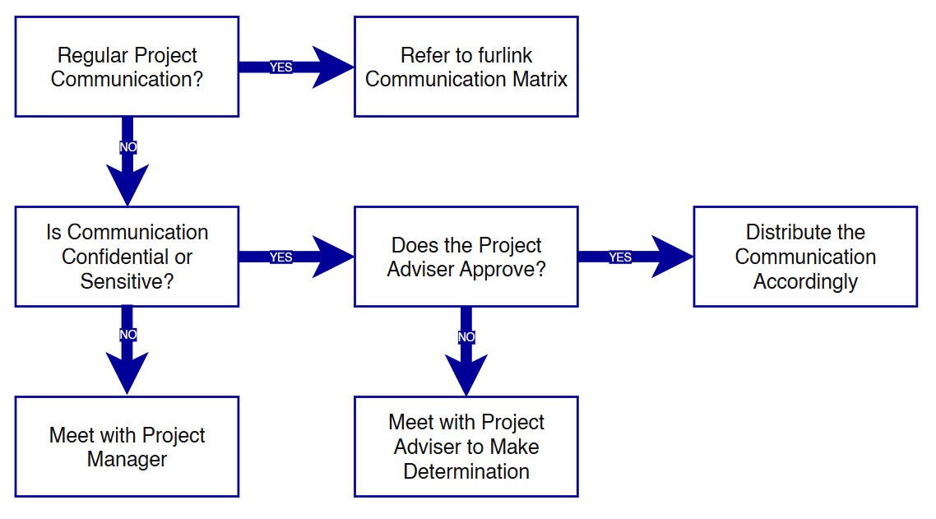

Guidelines for Meetings

Meeting Agenda
For meetings that are not the Sprint Planning, Daily Stand-Ups, and Sprint Retrospective, the meeting agendas will be distributed upon sending a calendar meeting request. The agenda should identify the main presented along with the maximum time for the meeting.

Meeting Minutes
Meeting minutes will be uploaded to the PROJMAN LogiTeh group channel within 2 business days following the meeting. Meeting minutes must follow the meeting minutes template uploaded in the group channel files and must contain action items.

Action Items
Action Items are recorded in the meeting minutes. Action items will include the action item along who must do the action item. Meetings will start with a review of the status of all action items from previous meetings and end with a review of all action items.

Meeting Chair Person
The Chair Person is responsible for distributing the meeting agenda, facilitating the meeting and distributing the meeting minutes. The Chair Person will ensure that the meeting starts and ends on time and that all presenters adhere to their allocated time frames.

Secretary
The Secretary is responsible for helping the facilitator adhere to the time limits set in the meeting agenda. The Secretary will let the presenter know when they are approaching the end of their allocated time.

Parking Lot
The Parking Lot is used by the facilitator to record and defer items which are not on the meeting agenda, however, it will be further discussed at a later time or through another forum. A parking lot record should identify an owner for the item as that person will be responsible for ensuring follow-up.

Communication Standards
For this project, the LogiTeh team will utilize standard Asia Pacific College (APC-SOCIT) formats and internal LogiTeh templates for all formal project communications. These communications, as detailed in the project’s communication matrix, include:
- Kickoff and Panel Defense: The project will utilize standard APC-SOCIT presentation templates. Formal meeting minutes and agendas will be drafted using LogiTeh document templates ad archived on SharePoint and team channels.
- Sprint Ceremonies: The project team will utilize standard OpenProject ticket formats to track tasks. Daily stan-up updates will follow a standaridized “Yester, Today, Blockers” reporting format in meetings and OpenProject Forum.
- Adviser Status Consultation: The team will use a standard Project Status Report to summarize milestone progress, budget health, and roadblocks prior to each meeting with the Project Adviser.
Informal project communication must remain professional and effective, but there is no template that must be used outside of the agreed-upon platforms.

Communication Escalation Process
Efficient and timely communication is key to successfully completing furlink by October 2026. Therefore, it is imperative that any disputes, conflicts, or discrepancies regarding project communications are resolved in a way that maintains the project schedule, ensures correct data distribution, and aligns with academic requirements.
To ensure the project stays on track, the LogiTeh team will use the following escalation model. This provides a clear hierarchy for resolving communication issues, defining priority levels, decision authorities, and required timeframes for resolution.
Priority Level | Definition | Decision Authority | Timeframe for Resolution
Priority 1: Critical | Major disputes or issues that affect the project’s viability, ethical compliance, or funding. | Project Adviser and Steering Commitee | Addressed immediately, within 5 hours
Priority 2: High | Conflicts involving project scope changes, academic grading and requirements, or external customer communication. | Project Adviser | Within 3 to 5 business days
Priority 3: Medium | Technical disputes regarding system architecture, GitHub merges, or API integration that may impact the sprint schedule. | Techical Lead and Project Manager | Within 48 hours
Priority 4: Low | Internal miscommunications regarding tasks, OpenProject tickets, or daily sprint goals and blockers. | Project Manager and Team Lead | Within 24 hours
** NOTE: Any communicarion including sensitive and/or confidential information will require escalation to Project Adviser for approval prior to external distribution.

Glossary of Communication Terminology
Term | Definition
Communication | The effective sending and receiving of information. Ideally, the information received should match the information sent. It is the responsibility of the sender to ensure this takes place.
Stakeholder | Individuals or groups involved in the project or whose interests may be affected by the project’s execution or outcome.
Communications Management Plan | Portion of the overall Project Management Plan which details how project communications will be conducted, who will participate in communications, frequency of communications, and methods of communications.
Escalation | The process which details how conflicts and issues will be passed up the management chain for resolution as well as the timeframe to achieve resolution.

Sponsor Acceptance
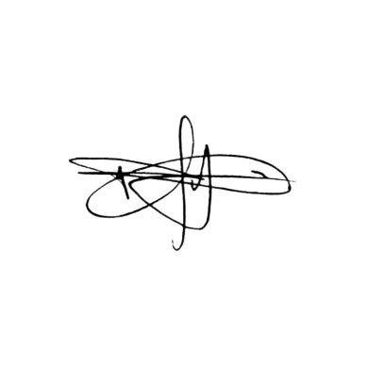
Approved by the Project Sponsor:

Date: April 7, 2026
Manuel R. Doria Jr.
Project Sponsor Representative

